|  |  |
| --- | --- |
| *Name* | *Cake* |
| *Color* | ***Pink*** |
| *Size* | ***5 inch*** |
| *Brand* | ***-*** |
| *Price* | ***PKR 300*** |

|  |  |
| --- | --- |
| *Name* | *Cake* |
| *Color* | ***Chocolate*** |
| *Size* | ***4 inch*** |
| *Brand* | ***-*** |
| *Price* | ***PKR 350*** |

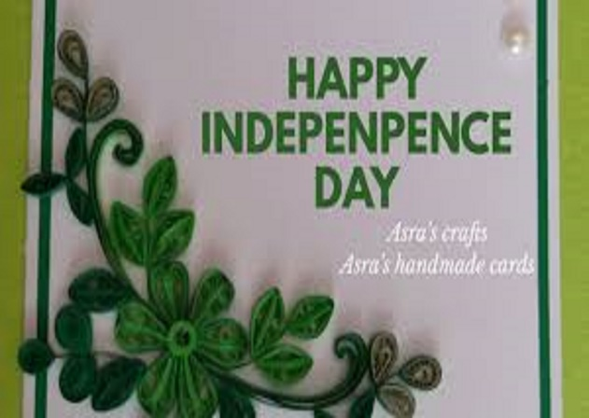

|  |  |
| --- | --- |
| *Name* | *Cake* |
| *Color* | ***Light Blue*** |
| *Size* | ***7 inch*** |
| *Brand* | ***-*** |
| *Price* | ***PKR 350*** |



|  |  |
| --- | --- |
| *Name* | *Cake* |
| *Color* | ***White*** |
| *Size* | ***2.7 inch*** |
| *Brand* | ***-*** |
| *Price* | ***PKR 350*** |



|  |  |
| --- | --- |
| *Name* | *Cake* |
| *Color* | ***Chocolate*** |
| *Size* | ***4 inch*** |
| *Brand* | ***-*** |
| *Price* | ***PKR 3500*** |

|  |  |
| --- | --- |
| *Name* | *Bracelet* |
| *Color* | ***Creem*** |
| *Size* | ***8 inch*** |
| *Brand* | ***-*** |
| *Price* | ***PKR 350*** |





|  |  |
| --- | --- |
| *Name* | *Cake* |
| *Color* | ***Crunch*** |
| *Size* | ***2.7 inch*** |
| *Brand* | ***-*** |
| *Price* | ***PKR 350*** |



|  |  |
| --- | --- |
| *Name* | *Cake* |
| *Color* | ***Brown*** |
| *Size* | ***6 inch*** |
| *Brand* | ***-*** |
| *Price* | ***PKR 350*** |

|  |  |
| --- | --- |
| *Name* | *Cake* |
| *Color* | ***White*** |
| *Size* | ***2.7 inch*** |
| *Brand* | ***-*** |
| *Price* | ***PKR 350*** |

